Key Quality 1 | Ask Yourself | Notes | Further Action(s) | People responsible | Resources / timeline | Evidence / Achieved
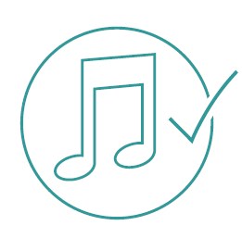  Value  Everyone involved in children and young people’s learning  understands the value of music education. | Does everyone involved understand and can they articulate the value of music education?
 | Does the school or preschool have a dedicated budget and resources for music?
 | Are there processes for the ongoing care and maintenance of instruments and equipment?
 | Do a broad range of staff contribute to the school’s or preschool’s music program?
 | Is there an appropriate learning environment with sufficient resources and storage space to enable quality music education?

Key Quality 2 | Ask Yourself | Notes | Further Action(s) | People responsible | Resources / timeline | Evidence / Achieved
Access  Every child and young person has access to inclusive and relevant music education activities. Music programs  recognise and respond to  barriers to success. | Is music embedded in the normal learning day?
 | Are music education programs accessible, relevant and responsive to the specific learning needs of Aboriginal students?
 | Have I addressed the principles of equity, accessibility and inclusion?
 | Are music learning opportunities adapted to ensure equity of access for students with a disability or learning difficulties?
 | Are there school-based and supplementary learning opportunities for students who need them?

Key Quality 3 | Ask Yourself | Notes | Further Action(s) | People responsible | Resources / timeline | Evidence / Achieved
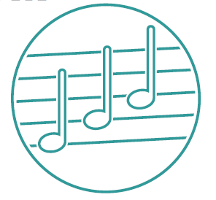  Continuum  Every child and young person  has the opportunity to engage in a continuous, sequential and  developmental music education  program, including through critical transition points such  as primary to secondary  school. | Can all our students access continuous, sequential and developmental music educaion?
 | Do we actively encourage participation in extra-curricualr music activities to further stretch our students’ learning?
 | Can we adapt and implement our music curriculum to ensure continuous, sequential and developmental music education?
 | Do we understand what prior knowledge and learning experiences our students are bringing to our program?
 | Are there opportunities to collaborate with local partners (such as feeder schools, community organisations, secondary schools)?

Key Quality 4 | Ask Yourself | Notes | Further Action(s) | People responsible | Resources / timeline | Evidence / Achieved
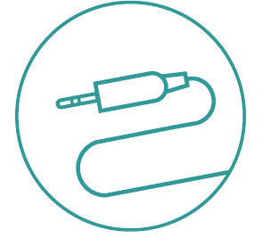  Connections  Strategic, sustainable and long-term partnerships enhance  music learning in the classroom.  Music education involves parents, families, communities,  schools, preschools and organisations. | Do we currently have any formal music partnerships within and beyond our site?
 | Do our partnerships enhance music learning opportunities for students?
 | Could we seek other partnership opportunities?
 | Are there shared goals and objectives between our schools or preschool and our partners?
 | Do we meaningfully connect with community organisations, parents, carers and families to reinforce student learning opportunities?
 | Do we have connections and opportunities in place for accelerated, high-achieving students?

Key Quality 5 | Ask Yourself | Notes | Further Action(s) | People responsible | Resources / timeline | Evidence / Achieved
Achievement  Every child and young person  has opportunities to develop their  interests, apply their skills and be  challenged by new knowledge  and experiences. | How are we monitoring the effectiveness of music education programs?
 | Is student success sustained and replicated?
 | Are there opportunities for extension for students demonstrating high achievement?
 | Do we share and celebrate music achievements in our school or preschool and within our wider community?
 | To what extent do our music programs demonstrate the qualities of value, access, continuum and connections?

