Exploring the SA Wellbeing and Engagement Data with Students: Resources

FACILITATOR’S RESOURCE LIST
 | RESOURCE | SLIDE
1 | 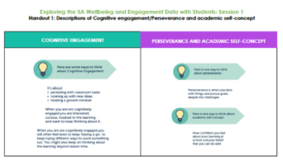  Descriptions of Cognitive engagement/Perseverance and academic self-concept | Slide 20 | HANDOUT 1  1 page  Make enough copies of this handout for participants to work in groups of 3.
2 | A3 Data Mat  – 1 page with Cognitive Engagement data and  1 page with Perseverance and Academic Self Concept data | Slide 25 | HANDOUT 2  2 pages  Make enough copies of this handout for participants to work in groups of 3.
3 | 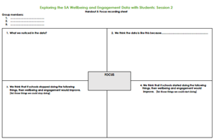  A3 Focus recording sheet | Slide 25 | HANDOUT 3  Make enough copies of this handout for participants to work in groups of 3.
4 | 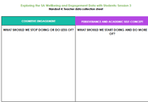  Teacher data collection sheet | Slide 39 | Make enough copies for each of the participating teachers.

