Exploring the SA Wellbeing and Engagement Data with Students
The sessions are approximately 30 – 40 mins each.
- Session 1– Slides 1-24: Introducing the SA Wellbeing and Engagement Collection
- Session 2 – Slides 25-38: Exploring and interpreting the data
- Session 3 – Slides 39-51: Moving forward from the data.

The notes to accompany each slide have been written ‘like a script’ for ease of presentation by the facilitator.

SESSION 1
Introducing the SA Wellbeing and Engagement Collection
TIME | FACILITATOR NOTES – SESSION 1 | SLIDES
3 mins | 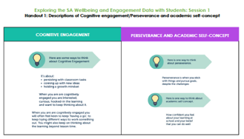  Handout 1:  Cognitive engagement/Perseverance and academic self-concept definitions  To be handed out with Slide 21.  SLIDE 1  - In the next 3 sessions we’re putting DATA in your hands – YOUR DATA. You are going to become expert advisors on this data. Today, In Session 1 we are going to introduce the SA Wellbeing and Engagement collection.  - In Session 2, you will become expert advisors in exploring and interpreting our data.  - In Session 3, you will focus on how to improve, to move forward using the data.
3 mins | SLIDES 2 – 4  Slide 2 (Animated)  - We have lots of data to choose from!  - Today we’re focusing mostly on the Wellbeing and Engagement data.  - We’re also sharing a little bit of NAPLAN achievement data, but that’s not the main focus for today.  Slide 3  - So, why do we collect data?  Slide 4 (Animated)  - Because we care!  - I’m sure that sometimes it doesn’t feel that way from your perspective, but I can tell you quite genuinely that we collect different kinds of data to try to understand what’s happening for every child and young person in South Australia, so that we can make the best decisions about your education. | 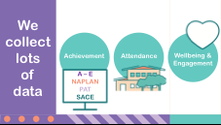
5 mins | SLIDES 5 – 11  Slide 5  - In just a few minutes we’re going to share some data with you, but before we do…  Slide 6  - Let’s collect some data of our own.  Slides 7 and 8  - Think about lunch-time yesterday. Rate your enjoyment of lunchtime yesterday using this scale – HIGH, MEDIUM, LOW.  - We’re going to be ‘no-tech’ in this data collection process. I’m just going to ask you to put your hand up (teachers as well).  - Hands up for HIGH…for MEDIUM…for LOW.  Slide 9  - So now we have some data about your enjoyment of lunchtime. And I’ve created a graph showing what I thought it might look like – so let’s see how close I was.  - Does my graph represent what our experience of lunchtime yesterday was? Which coloured section should have been larger, or smaller, for it to be more accurate?  Slide 10  - The problem is, that data about lunchtime just tells us WHAT you think and we have no information about WHY you think that, or how we can improve your enjoyment of lunchtime. | 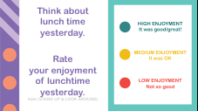  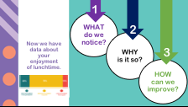
1 min | SLIDES 11-12  Slide 11  - Let’s warm up your data brain - that’s not a real thing, but you get the idea!  SLIDE 12  - We are going to meet the data set.
5 mins | SLIDE 13 – 18  Slide 13  - The data set we’ll be working with is called The Wellbeing and Engagement Collection, or WEC for short.  Slide 14  - It looks like this. Here’s a photo of a South Australian student doing the survey.  - You can see an example of the type of question you are asked in this survey. You give a rating just like we did when we were rating lunch time.  Slide 15 (Animated)  - Take a guess with the person sitting next to you, “How many students do you think did the WEC survey this year?”  - Imagine this red dot is you completing the WEC survey.  - That’s you, sitting in a group of a thousand students all doing the WEC survey.  Slide 16 (Animated)  - And there you are sitting in a group of ten thousand students.  Slide 17 (Animated)  - You are still there in a group of ten thousand students, and there’s another ten thousand and another five thousand four hundred and thirty-six (is that getting close to your guess!?) and the whole of the Adelaide Oval is FULL to capacity with students all doing the survey.  - That’s almost 80 thousand students from 452 public schools in South Australia who participated in this survey this year. This is important data to us. | 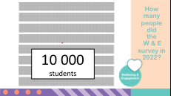  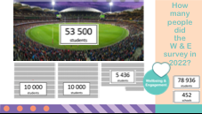
10 mins | SLIDES 18 – 24  Slide 18  - Today we are going to become expert advisors in either:  - COGNITIVE ENGAGEMENT  OR  - PERSEVERANCE AND ACADEMIC SELF CONCEPT.  - Form groups of three.  - What do you think each of these ‘terms’ mean?  - Share your thinking in your group. Don’t worry if you’re not sure what that is yet!  2 minute buzz.  Slide 19  - Let’s START building our expertise…take a look at the descriptions of Cognitive engagement/Perseverance and academic self-concept on your table (Handout 1).  Slide 20 (ANIMATED)  - We’re going to think, pair, share for about 3 minutes.  - Talk with a neighbour and decide who is going to focus on Cognitive engagement and who will focus on Perseverance and Academic self-concept.  - Read first, and then share in your words, what you think it means with your neighbour.  - Then discuss as a table group.  Slide 21  - We are going to keep building our expertise in Cognitive engagement/Perseverance and academic self-concept.  - This time we are going to play a short game and then relate it to our ‘expert’ field.  Slide 22  - The game uses this picture, but before I go any further, I’m going to need a helper at each table.  - It’s best if you’re a bit bossy – you know, the good bossy. Someone who is really organised, helps us all stay on task, gets things done and is good at reminding people what they should be doing. Who is that person at your table? Thank you.  - Now point to the person to your left because they are going to have a special job as well.  Slide 23 (ANIMATED)  - And the question is just – Which one doesn’t belong? Why? Is there another answer and another one and another one…keep going!  - If you are the table helper your job is to keep asking people for another answer, what else, what else…  - Person to the left, your role is to make sure everyone is included. Please notice if someone isn’t being heard and include them.  - OK – 2 minutes – off you go – Which one doesn’t belong? Why?  START 2 MINUTE timer.  Slide 24  - Connect what you did in the game to your expert topic:  - Were you cognitively engaged with the game? Were you keen to keep having a go? Are you still thinking about the game?  - Did you have high or low persistence in thinking of new ideas of which one did not belong? Why?  - Were you feeling confident that you could come up with some ideas?  2 minute buzz.  - Today we have spent time on understanding the terms Cognitive engagement, and Perseverance and Academic self-concept. In the next session we will use choose one of these as a focus to explore and interpret the data. | 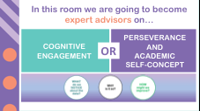  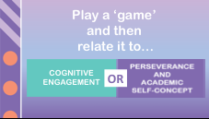  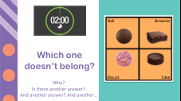

SESSION 2
Exploring and interpreting the data

TIME | FACILITATOR NOTES – SESSION 2 | SLIDES
8 mins | 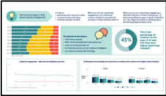  Handout 2:  A3 Data sheets.  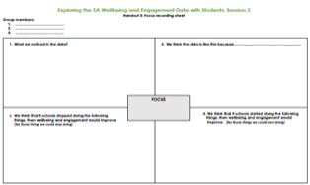  Handout 3:  A3 Focus  sheet.  To be handed out at the beginning of the session.  * Both of these hand-outs will also be needed for Session 3.  SLIDES 25 - 29  Slide 25  - Today we will be working in our groups of three again to become expert advisors in exploring and interpreting our data.  - Take a quick look at the A3 Data sheets – we’ll be working with this data today and the next session.  - On the Focus sheet:  - Write your names in as the ‘authors’ of the document.  Slide 26  - In the last session we got our definitions for Cognitive engagement, and Perseverance and academic self-concept.  - As a group choose your focus. On the Focus sheet:  - Write your focus in the middle box: Cognitive engagement OR Perseverance and academic self-concept.  - Now you are going to use that focus to think about the data we look at today.  Slide 27 (ANIMATED)  - Let’s add some more ideas to our thinking by listening to this animation.  - There is a question for you at the top or bottom of the screen (colour coded).  - Think about the animation and look at these pictures. Be a sort of detective:  - What do you think the clues might be that suggest they’re cognitively engaged/are showing perseverance and perhaps have strong academic self-concept?  2 minute buzz.  - Notice the young boy (top left) he doesn’t look ‘excited/happy’ but he’s definitely thinking deeply.  - Being cognitively engaged doesn’t need to look happy. It might be exciting, but it doesn’t need to be. It’s more about you getting caught up in the thinking, sometime so caught up you can’t stop thinking about it.  - I heard some of you suggesting that he looked like he was persevering because he was thinking about something challenging and that he probably believed it was worth persevering with because he believed in his ability to succeed – having a strong academic self-concept.  Slide 28 (ANIMATED)  - What did your ‘expert topic’ look like, sound like and feel like in the game and the learning pit video?  2 minute buzz.
5 mins | SLIDE 29  Slide 29  - OK, Let’s get into our data sets about Cognitive engagement OR Perseverance and academic self-concept.  - I’m going to give you 5 minutes.  - Look at the data:  - WHAT do you notice?  - What do you think it’s telling us?  Just CHAT – no need to write anything.  START 5 MINUTE timer. | 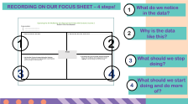
15 mins | SLIDES 30 - 31  When students are recording their thinking for each of the four questions circulate around the room and take notes of what they are saying.  Slide 30  - Now it is time to think about what the data is telling us.  Slide 31 (ANIMATED)  - In your group, discuss the A3 Data sheets from your ‘expert’ focus.  - Use the questions on the screen to help you focus your discussion.  START 7 MINUTE timer.  Slide 32  - On your Focus sheet record your group’s thinking about what you noticed about the data.  Slide 33  - Cognitive engagement people, this is what we are hearing from you…(Comment on what you heard the students saying while circulating).  These are some of the things we are hearing from students around the room:  - I notice the green section – the ‘Highly cognitively engaged section’ gets less as students get older, although it gets a bit better in senior secondary.  - I notice that on average fewer than half of students say they are highly cognitively engaged.  - I notice that cognitive engagement isn’t getting better over time. Maybe even a little bit worse.  - I notice that high-band NAPLAN goes down as students get older and I wonder if that’s connected to students’ engagement?  - Perseverance and academic self-concept people, this is what we are hearing from you……(Comment on what you heard the students saying while circulating).  These are some of the things we’re hearing from students around the room:  - I notice that the green bits that show high perseverance and high academic self-concept get smaller for older students.  - I notice that almost a quarter of the oldest students say they have very low perseverance.  - I notice there are fewer students getting high NAPLAN scores in the older year levels and I wonder if this is connected to perseverance.  - Let’s think for a minute what that data means for the people in our class:  - Does this mean that nearly half of us of us may not be highly cognitively engaged with our learning?  - How many of us may stop persevering when the work gets challenging?  2 min buzz. | 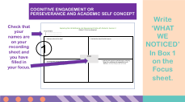  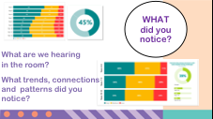

12 mins | SLIDES 34 – 38  Slide 34  - Now it is time to think about why you think our data looks like this.  Slide 35 (ANIMATED)  - On your Focus sheet record your group’s thinking about why you think the data looks like this.  START 5 MINUTE timer.  Slide 36  This is another way of representing the data.  - What do you notice?  - I notice that perseverance is getting a little bit worse over time and so is academic self-concept.  Slide 37  - And another way to think about this data.  - Let’s think for a minute what that data means for the people in our class, because today you’re representing more than just your own views.  - Imagine a class of 28 students:  - How many of those students have low perseverance?  Slide 38 (ANIMATED)  - Let’s do some more thinking about why the data looks like this:  - Look at the picture on the left (under the pale green circle) Only the students in green are really persevering with their learning.  - Look at the picture on the right. Only the students in green really strongly believe they can do well.  - On average 3 students in a year 4 class are not ‘hooked into their learning’- not cognitively engaged.  - And by year 9 almost a quarter of a standard class aren’t engaged with their learning and far fewer of them are highly engaged than in younger year levels.  - Add any new thinking to your Focus sheet.  START 5 MINUTE timer.  - We have done a lot of great thinking today about why we think the data is like it is. In the next session we will focus on what we might need to stop doing, start doing and do more of, to move forward from the data. | 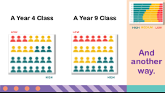
SESSION 3
Moving forward from the data

TIME | FACILITATOR NOTES – SESSION 3 | SLIDES
1 min | 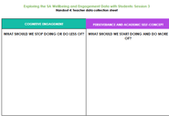  Handout 4:  Teacher data collection sheet  SLIDE 39 – 40  When students are working in their groups circulate around the room and take notes of what they are saying.  Also, put some blank A4 paper on each table; enough for 1 piece per group.  Slide 39  - Today we will be working in our groups of three again.  - Make sure you have your A3 Data sheets and Focus sheet to work with again in today’s session.  Slide 40  - Now we’re shifting gear. You’re becoming more comfortable with your EXPERT focus and through looking at the data you have some expertise in what students across SA have to say about Cognitive engagement and Perseverance and Academic self-concept.  - Now we are going to look at how we might improve.
10 mins | SLIDE 41 – 42  Slide 41  - In your group, choose a piece of data from the A3 Data sheet to focus on; where you would like to see improvement.  Slide 42  - Share your thoughts about why you think this piece of data is like it is. For example, you might choose to look at the Year 4 -12 Cognitive Engagement – High, Medium and Low OR the percentage of students who feel confident about their academic success.  - We need to really think about why the data is like it is so that we can think about what we might need to do less of, and more of, to improve, to move forward.  - Remember – be brave in sharing ideas even if you haven’t thought them through fully – share with your group. Be kind in the way you express your ideas.
1 min | SLIDE 43 – 44  Slide 43  - Brilliant! Thank you for sharing your ideas in your group.  - I heard some of you…(Comment on what you heard the students say while circulating – at least 2).  - We will now concentrate on what we need to STOP doing.  Slide 44  - Let’s shift gear now and think about HOW we’ll improve, what we should stop doing or do less of.
10 mins | SLIDE 45  Slide 45  - Improvement often involves BOTH starting (or doing more of) some things AND stopping (or doing less of) other things.  - If, for example, I wanted to get healthier I might start exercising, or exercise more, and eat fewer cream buns.  - So, I know it sounds like a crazy thing to ask, but for the next 10 mins we’re asking you to brainstorm all of the things you can think of that stop you (and others) from being cognitively engaged OR stop you from persevering with your learning and believing that you can succeed?. Use the questions on the screen to help you with your thinking.  - Think of things that stop you from being hooked into the learning, because these are the things we need to do less of or stop!
5 mins | SLIDES 46 - 47  Slide 46  - Share your group’s best idea of what we should be doing less of with the whole group.  Slide 47  - Imagine that, in our school, we have been acting on the things that we should stop doing, or do less of.  - What do you do you hope to see happening to Cognitive engagement and Perseverance and Academic self-concept in 3 year’s time?  Slide 48  - We are continuing our thinking about improvement, but shifting now to think about what we will start doing, or will do more of.  - So, imagine we’re in the future and our data has improved.  - Choose one of the questions at the bottom of the screen and discuss in your group what you think might be happening that has made students more cognitively engaged, are persevering more and have stronger belief in themselves as learners.  2 min buzz.
15 min | SLIDES 49 – 50  Slide 49  - For the next 10 mins we’re asking you to brainstorm all of the things you can think of that would help you (and others) be cognitively engaged OR help you persevere with your learning and belief that you can succeed?.  - Think of things that really help you get hooked into the learning, make you want to persevere because you believe you can succeed. These are the things we need to do start doing, or do more of!  Slide 50  - Copy your group’s best idea onto a piece of blank paper and place in the middle of your table.  - Now, get up and do a gallery walk around each table to see the great ideas that you have all come up with. | 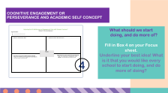
1 min | SLIDES 51  Slide 51  - Over the past 3 sessions we have focussed on:  - What we noticed about the data.  - Why it is so, and  - How might we improve.  - We will collect your Focus sheets now to make a list of suggestions about what we should stop doing or do less of, and what we could start doing and do more of, to help us improve.  - We will then be focussing on how we can work together in the future to put our ideas into practice.  Teacher collates all the ideas onto the collation sheet and publishes this for students to consider, “What could we try straight away?’  Thank you for your deep thinking and input of ideas to move forward from the data. Most impressive! | 