
Intravenous (IV) care instruction
for education and care

‘I get a bit scared that my arm or chest will get knocked at school with the drip in.
But I want to be at school a hundred times more than in hospital’ (Student)

Intravenous Therapy is when medicines or nutrition are administered directly into the blood stream. Sometimes children and young people require long term intravenous therapy such as chemotherapy (cancer drugs), prolonged antibiotics therapy, nutrition or frequent blood sampling. Although the children and young people are well enough to continue with normal activities, to avoid discomfort and repeated injections, they may have an intravenous device left in between treatments. The types of intravenous devices are listed in more detail below.
Some examples of the types of diseases the children may have that require prolonged intravenous therapy are cancer, infections in the bone (oesteomyelitis), metabolic disorders or cystic fibrosis.

Peripheral Intravenous Catheter (PIVC)
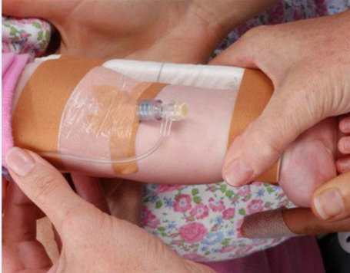 | PIVC lines or ‘drips’ administer medication directly into the bloodstream. A PIVC is a short cannula inserted into a small vein usually in the arm.  They are used for short term intravenous access.  An arm board may be used as a splint to prevent damage from excessive movement of the PIVC.  The PIVC is taped to the skin and covered with a transparent dressing to prevent infection. The whole lot is covered with a bandage for security.  Children and young people with a PIVC cannot play contact sports or swim but can participate in all other learning activities which do not threaten to dislodge the PIVC.
Central Venous Access Devices (CVAD)
CVADs are used for medium to long term intravenous therapy. The age of the child and the type of treatment determines which CVAD is used.
CVADs are used either when the treatment needs to be delivered directly into the bloodstream through a big vein or because the device needs to stay in for a longer period of time. These devices can be used for fluids, medicines, nutrition, chemotherapy and to take blood.
There are different types of CVADs, some have one tube (single lumen) while others can have two tubes (dual lumen) or three tubes (triple lumen). The different types of CVADs are listed below.
Peripherally Inserted Central Catheter (PICC)  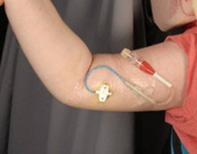 | A PICC line is a long, thin, flexible tube that is threaded, through a vein usually in the upper arm with the tip terminating in a large vessel. The line is flexible, so does not need to be secured with an arm board. The PICC may be stitched or taped in and covered with a transparent dressing. The PICC is covered with a bandage at all times to prevent accidental removal.  Contact sports, playing in the sandpit and activities that could dislodge or damage the line should not be undertaken. Swimming is not allowed as the PICC must stay dry at all times.  Sharp implements such as scissors and power tools should not be used near the line. Children and young people can participate in all other learning activities which do not threaten to dislodge or break the line.

Central Venous Catheters (CVC)  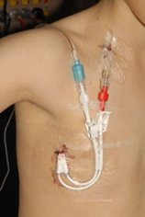 | A CVC is a long, thin flexible tube that is inserted into a large “central “vein in the neck and tunnelled under the skin so the CVC exit point is on the chest wall. Treatment is delivered into a large vein.  A clear plastic dressing will cover the catheters exit site at the skin. The clamp on the catheter should be closed at all times when the catheter is not in use.  Contact sports, playing in the sandpit and swimming are not allowed as this could dislodge the catheter or cause an infection.  Sharp implements such as scissors should not be used near the CVC. Children and young people can participate in all other learning activities which do not threaten to dislodge or break the line.
Port  Some children and young people will have a permanent port implanted under their skin to enable administration of intravenous medication.  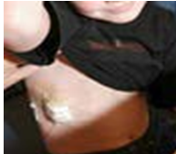 | When the port is not being used for medication, all that can be seen is a slight bulge under the skin in the chest wall. When medication is administered, a 90 degree angle needle is inserted through the skin into the port. The needle stays in for two to four weeks while the medication is administered. The needle is changed every 7 days. A needle is not always in place.  A special dressing is applied over the needle to keep it securely in place and prevent infection.  Children and young people with ports cannot play contact sports, and if they have the needle in, they must not go swimming. If there is no needle they can participate in all other activities.  Falling directly onto a port can cause skin or bone injury. Notify parents immediately if the child has a fall, gets knocked, oozing or there is redness around the sight

Baxter Pump
A Baxter pump is a disposable pump which contains a balloon inside the casing. The balloon contains the child or young person’s medicine which is pushed into the line by the balloon slowly deflating.
The Baxter pump does not use batteries and does not make a noise. The Baxter pump is held in a bag (or clean sock) that is pinned to the child’s clothes with a safety pin or connected to a belt and worn around the child’s waist. It remains connected for 24 hours. Each bottle lasts for 24hrs but treatment can range between 1-8 weeks.
The child or young person with the pump and other children should be discouraged from touching or playing with the Baxter pump. Other pumps can also be used.

INTRAVENEOUS FIRST AID

OBSERVABLE SIGN |  |  | FIRST AID RESPONSE
 | The line comes out completely | ⇨ | ⇨ | Hold pressure on the skin with gauze or 3-5 minutes to stop the bleeding.  When the bleeding stops apply a bandaid.  Notify the parent or legal guardian.
 | The line partially comes out | ⇨ | ⇨ | Tape the visible line to the child or young person’s skin without removing the dressing.  Notify the parent or legal guardian.
 | The line breaks and no blood or fluid comes out | ⇨ | ⇨ | Cover the end of the line with a sterile bandage.  Notify the parent or legal guardian.
 | The line breaks or is leaking and blood or fluid comes out | ⇨ | ⇨ | Clamp off (or pinch the line if there are no clamps between the exit point and the break).  Place clean gauze over the end of the line, tape the visible line to the child or young person’s skin.  Notify the parent or legal guardian.
 | The clear dressing partially comes off | ⇨ | ⇨ | Notify the parent or legal guardian.
 | It is wet under the clear dressing | ⇨ | ⇨ | Notify the parent or legal guardian.
 | There is blood under the clear dressing | ⇨ | ⇨ | Notify the parent or legal guardian.
 | The line becomes disconnected from the Baxter pump | ⇨ | ⇨ | Notify the parent or legal guardian.
 | The child or young person develops a temperature or becomes unwell | ⇨ | ⇨ | Notify the parent or legal guardian.

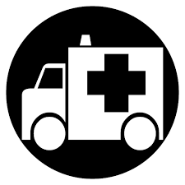 | If parent or legal guardian is unable to be contacted or unavailable to collect the child or young person (particularly if there is a break and blood loss) an ambulance must be called immediately.  Call 000 and request an ambulance

