_____________’s regulation scale

Regulation zone |  |  | Why do I feel like this? | What signals am I getting from my body (interoception)? | What can I (or someone else) do to help?
Panic Zone | SNS overload
Panic Zone | SNS dominant
Learning Zone | Slight SNS dominance
Learning Zone | Homeostasis
Comfort Zone | PNS dominant

Regulation Zones
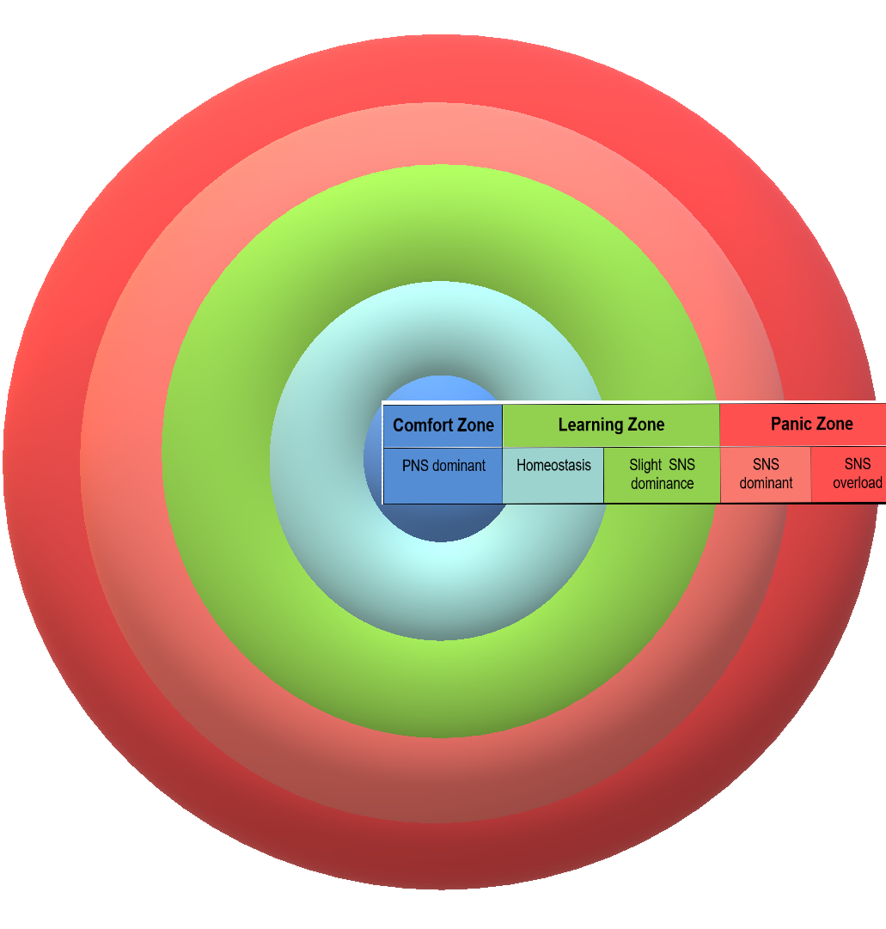
Our Comfort Zone is our resting, regulated zone. Sometimes it might be difficult to identify how our body feels in a relaxed state. While this can be a nice zone to be in, sometimes we have to move out of our comfort zone to learn new things or try something different.
Being in the learning zone means we might feel our heart rate increase or other signals from our body (hands sweating, swirly stomach, tightness in the neck) or feel a bit uncomfortable, but this is good stress. It means our brains are being challenged to think outside our comfort zone and learn new things. Sometimes, even though being in the learning zone can be new and scary, when we are in this zone we achieve things we didn’t know we could do before. This can be very exciting and make it worthwhile. When we are in the learning zone, it may not always feel like we are learning as quickly as we want to, and we might get frustrated. But brains are amazing things and they are absorbing new information all the time, even if it doesn’t feel like it. It may take a while, and that’s okay. Be gentle with yourself and give yourself credit for trying.
If we have difficulty recognising or interpreting the signals from our body (interoception), these signals can be perceived by our brains as danger. This sometimes triggers a ‘flight, fight, freeze’ survival response and we might find ourselves in our panic zone. When we are in this zone, we may find it difficult to think, reason or understand what is going on around us.
Many children and young people need to be explicitly taught how to identify each zone (comfort, learning, panic), how it feels/looks/sounds for them when they are moving between zones and what calming activities (interoception, yoga, breathing) work for them to reduce the chance of escalating into survival response.

