For best results and effective implementation this form should be completed in collaboration with education staff, families and the child or young person to develop agreed strategies that can be applied at school and home. This template should be used for one behavior at any time.

Name of child/young person: |  | DOB:
Education or care service:
Contact staff member(s):
Understanding behaviour lays the foundation for how we support children and young people displaying behaviours of concern. A proactive approach to this involves an organised and planned approach to decrease or prevent the likelihood of the behaviour occurring and/or recurring.
Everything we do and say is behaviour. All behaviour serves a purpose and is driven by an individual’s needs. The same behaviour can serve multiple purposes, and multiple behaviours can serve the same purpose. Look for common behaviours. To identify the purpose of a behaviour we need to consider what happens BEFORE the behaviour as well as AFTER the behaviour.
Just because a behaviour is annoying doesn’t mean we need to change or stop the behaviour. Ask yourself:
Is the child or young person physically hurting themselves or others?
Is the behaviour interfering with the child or young person’s learning or the learning of others?
Is the behaviour limiting access to every day experiences, settings or services?
Is the behavior suggestive of a need to adapt curriculum/setting to accommodate child’s particular needs?
Identify the behaviour
Write the behaviour that you wish to replace in the centre box ‘The Behaviour’. Consider what happens before and after the behaviour. The most likely/least likely table (page 3) will assist to gather information about when the behaviour happens and under what circumstances, as well as when the behaviour doesn’t happen. Using this table can help you to question your assumptions about the behaviour. At this stage you are fact finding to gather information about the behaviour. The more accurate this information the more likely you will be able to develop an accurate plan. Document your findings in the before and after behaviours sections.
Identify the purpose
The purpose of a behaviour is usually to either get or get away from someone, an object or activity, a sensory disturbance or for help. When determining what the purpose(s) of the behaviour is consider what might be the implications of misunderstanding the purpose. Document all possible purposes of the behaviour.
Plan the intervention
Behaviours can be replaced by new (more appropriate) behaviours provided it serves the same purpose. Write the new behaviour you want to START, or the new skills you want to introduce, in the middle section of the bottom row. Document any environmental changes (these are often the easiest to introduce and can have the greatest impact). Document strategies that will assist in teaching the child or young person the new behaviour or skills (use their special interests). Document specific rewards or reinforcements for the new behaviour (these should be given immediately when initially teaching the new behaviour or skill).

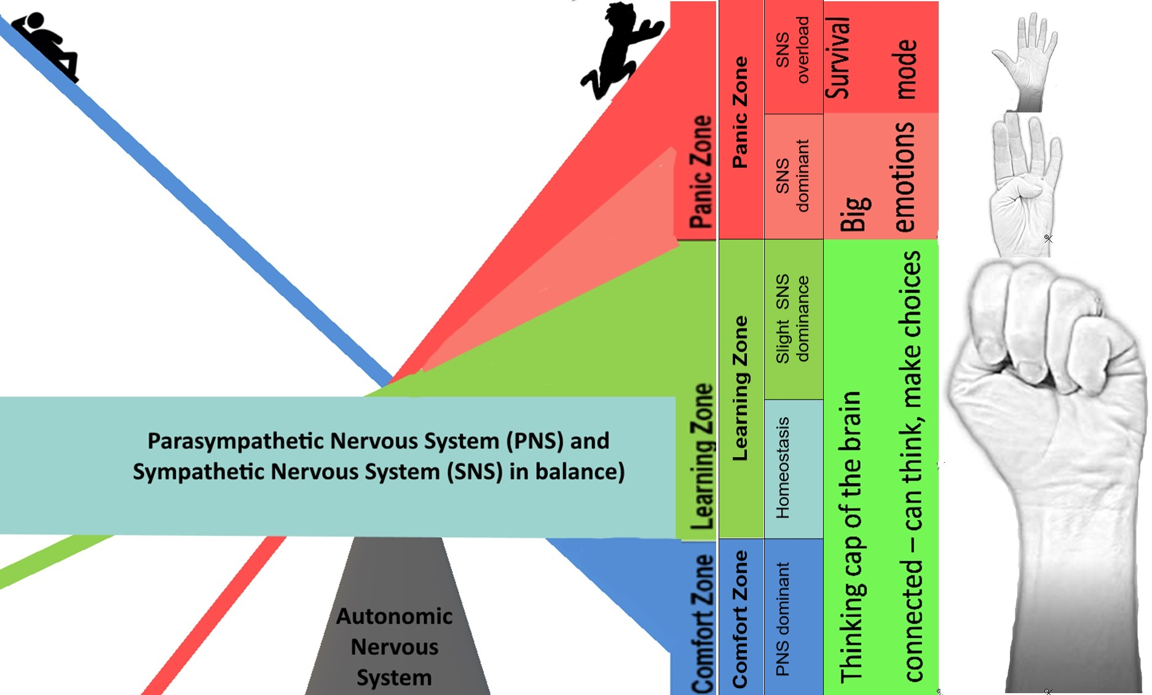

Identify the behaviour |  | Before the behaviour |  | The behaviour |  | After the behaviour
 | 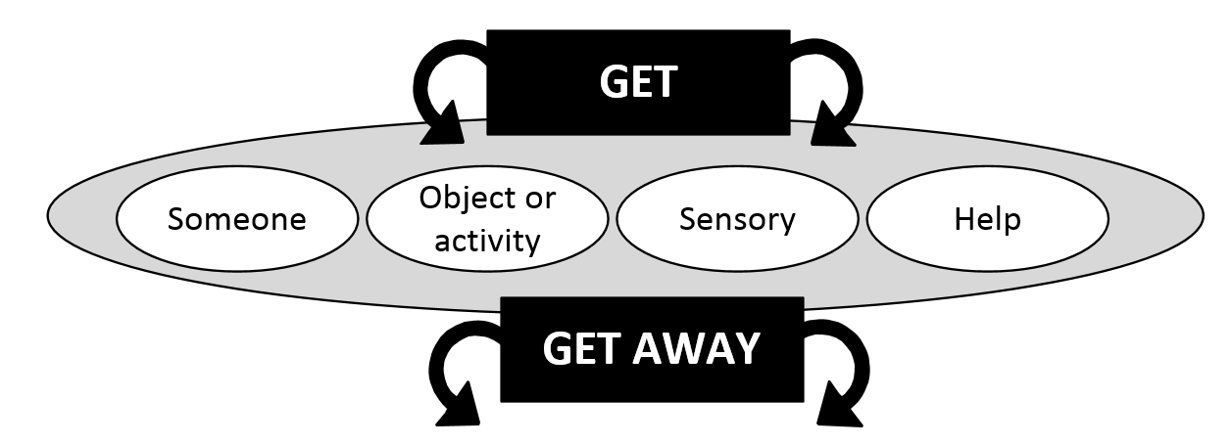
Identify the purpose |  |  |  |  |  | Purpose of the behaviour
Plan the intervention |  | Environmental change |  | Replacement behaviour |  | Reward / reinforcement for replacement behaviour or new skill
 |  |  |  | Teach new skills
 |  |  |  |  |  | Review date:
Most likely / least likely table

 | People | Place | Activity | Time | Regulation Zone
Most likely | Who is usually around when the behaviour occurs? | Does the behaviour only occur in one (or only a few) places? | Think about activities that are happening during; but also activities immediately prior to, or when the child knows an activity is about to commence | Is there a time of day, day of week, etc when the behaviour is likely to occur? | Refer to the regulation scale hyperlinked <here>  PANIC ZONE
Least likely | Who is never around when the behaviour occurs? | In what places does the behaviour never occur? | What activities are least likely to prompt challenging behaviour? | Is there a time when the behaviour is not likely to occur? | Comfort  Zone  Learning Zone

