Good ways to build schools for students living with disability
This document has some hard words.
The first time we write a hard word it is in blue.
We write what the hard word means.
You can ask for help to read this document.
A friend, family member or support person may be able to help you.
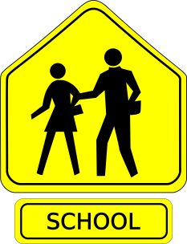
What is this about?
This is about making schools good for everyone to use.
The buildings must be OK for everyone to use.
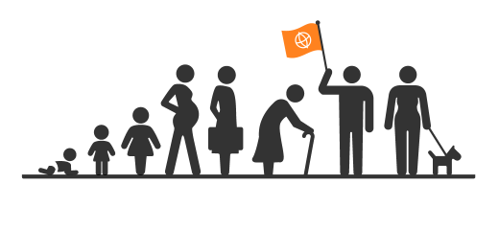
This is called Universal Design
Universal Design means buildings are made so everyone can use them.

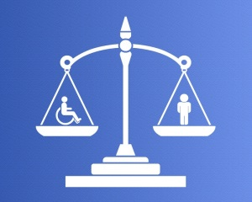
Everyone has a right to education
All children living with disability have a right to an education.

They have a right to go to school.
A right is something you are born with.
It cannot be taken way.
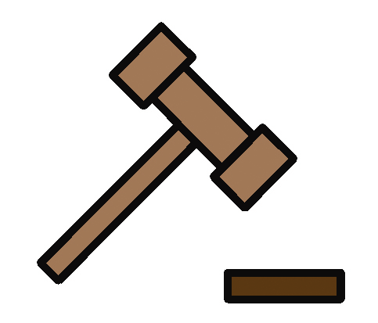There is a law.

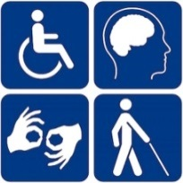
The law says a child living with disability has a right to go to school.

This law is the Disability Discrimination Act 1992
Discrimination is where you treat someone differently because they have a disability.

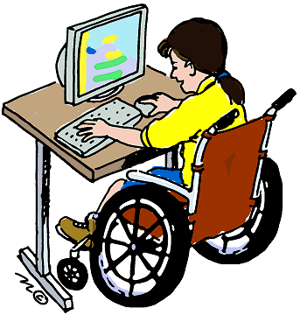
Buildings must be accessible.
Education buildings must be accessible.
Accessible means everyone can use it.
All children must be able to get in and around their school.
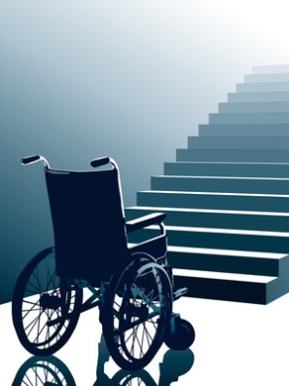
Sometimes the school has stairs.

Sometimes the school does not have equipment.

Sometimes the classes are too hard.

This is wrong.
When people build new schools it should be for everyone.
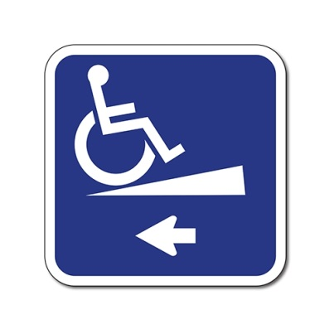
What the people can do
People can put things in schools that help students living with disability.
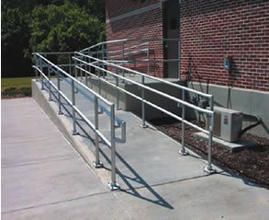
These are
Ramps

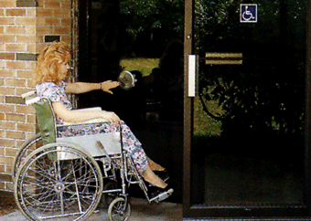
Doors that are easy to open

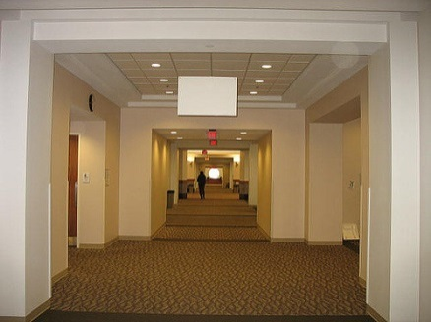
Wide doorways and hallways

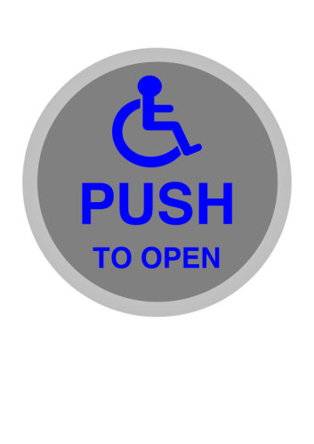
Buttons and controls

People living with disability are all different.
People must remember this when building new schools.
Teachers need to know how to use equipment.
All students must be supported.
All students must be safe.
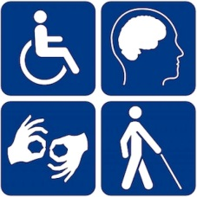
Who should be asked about building schools
Ask people living with disability
People building schools should ask students what they need.
Young people living with disability can help design buildings. They are the experts.

Ask experts
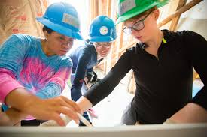
There are people who know lots about Universal Design.
People who build schools should ask them.
What you can do
You can talk to the school about what you need.
Find the full report on the internet

Contact
Ministerial Advisory Committee: Children and Students with Disability
Phone 08 8226 3632

Email decdminadv@sa.gov.au

Image attribution: Universal Design Linkedin

