School staff induction checklist: student behaviour including bullying and violence

School staff play a vital role in supporting student learning, wellbeing, health needs and behaviour. Use this checklist of department resources and Plink online training modules to help you build your skills to support students at risk and manage incidents like bullying. Tick them off as you go.
Start here | Talk to your line manager about your school’s approach and where to find your Behaviour Support Policy and Bullying Prevention Policy on your school’s website.

Policies and procedures
 | Bullying prevention requirements  Information and recommended resources on overarching policies, reporting and resolution processes, definitions and examples of bullying, harassment, discrimination.
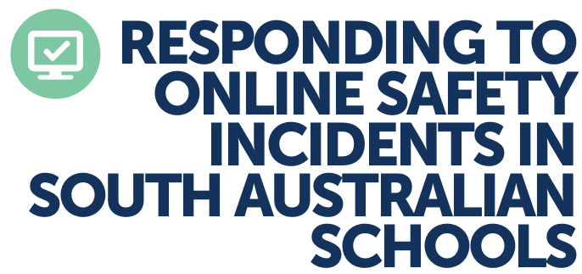 | Responding to online safety incidents in South Australian schools  These guidelines help school staff consistently respond to online safety incidents and recognise when escalation or interagency coordination is needed.

Training to help you understand and respond to bullying behaviour
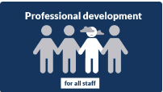 | Bullying prevention online learning modules  Use the online learning modules to build knowledge and skills to support positive behaviour, create safe environments, identify bullying, and address behaviour concerns.  Module 1 – Understanding bullying  Module 2 – Strengthening relationships for safe and supportive communities  Module 3 – Providing effective interventions and support  Module 4 – Cyberbullying  Module 5 – Preventing and reducing bullying for children and young people at highest risk  Module 6 – Working with parents to prevent and respond to bullying

Tools and resources to help you understand and respond to bullying behaviour
Bullying prevention – educator tools and resources
Youth Law Australia Bullying prevention lessons
Diversity and inclusion videos with practice guidance
Racist bullying videos with practice guidance
Guides to share with parents about cyberbullying and online safety
Bullying presentation for a parent information session.
Changing the physical environment
Help and support for families and other external agency supports

Other training and resources to help you understand and respond to student behaviour
 | Violence prevention dashboard  Don’t stop here! find more behaviour and violence prevention related training  and resources on the Plink dashboard.

