SSO training checklist: student behaviour including bullying and violence

As a School Services Officer, you play a vital role in supporting student learning, behaviour, and creating a safe and inclusive environment. Use this checklist of Plink online training modules to help you build your skills to support students at risk and manage incidents like bullying and violence.

Each module of training takes less than one hour to complete. You can follow the recommended order in the checklist or choose those most relevant to your role. Tick them off as you go.
Start here | Talk to your line manager about your school’s approach and where to find your Behaviour Support Policy and Bullying Prevention Policy on your school’s website.

Courses to help you understand student behaviour including bullying and violence
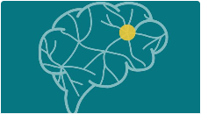 | An introduction to trauma-informed practice in education  Recognise the neurobiological impacts of trauma on students, and develop effective  strategies to support their development, wellbeing, behaviour and learning.
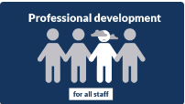 | Bullying prevention module 1 – Understanding bullying  Explore key definitions, the different types of bullying and the impact it has and use  effective practices to address behaviour concerns when they occur.
Bullying prevention module 4 - Cyberbullying
Learn about cyberbullying and how to implement effective interventions to support
respectful and safe online behaviours in your school.
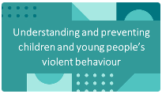 | Understanding and preventing children and young people’s violent behaviour  Understand violent behaviour in childhood and adolescence, what causes it and identify things you can do to minimise the risk of violence and support children to be safe from harm.

Courses to help you recognise student behaviour including bullying and violence
Bullying prevention module 5 – Preventing and reducing bullying
Prevent and reduce bullying for children with disabilities, children in care, Aboriginal
children, children from diverse backgrounds and gender and sexually diverse children.
 | Gender diverse, intersex and sexually diverse children and young people  Gain knowledge of legislation, policies and inclusive practices to support and affirm gender diverse, intersex and sexually diverse children and young people in educational settings.

Course to help you respond to student behaviour including bullying and violence
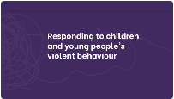 | Responding to children and young people’s violent behaviour  Learn to identify, respond to, and manage behaviours of concern by applying  effective strategies to keep students safe and minimise future risks.

Continue  learning | Violence prevention dashboard  Don’t stop here! find more training and resources on the dashboard

