# Student choice example flashcard – student volunteer program

You can create flashcards to help your students think about their interests and passions. This is one example to get you started.

## Example flashcard

What am I passionate about?

### The environment

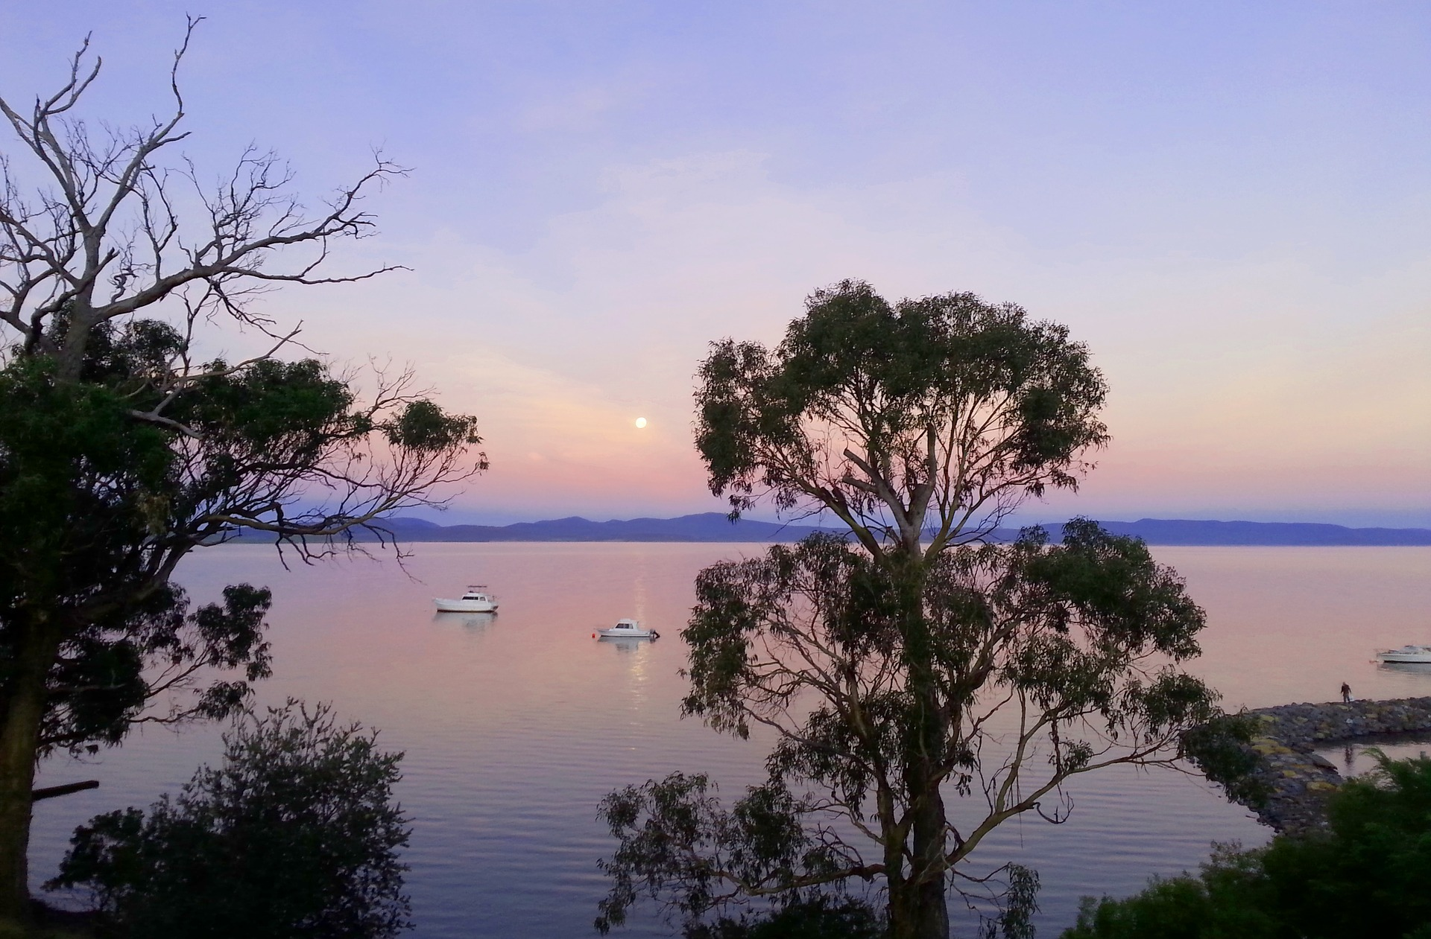

This image was sourced from <https://pixabay.com/en/australia-gumtrees-boats-water-3395517/>   
This website has images that are free for commercial use and don’t require attribution.