This information is confidential and will be available only to relevant staff and emergency medical personnel.
This form must be completed by the child’s treating medical practitioner or Diabetes Nurse Educator.
Glucagon medication agreements that are modified, overwritten or illegible will NOT be accepted.

Name of child or young person:
Date of birth: |  | Date of next review:
Allergies:
Education or care service:
Education or care service email: (if known)

MEDICATION INSTRUCTIONS
To be used in the event of a moderate to severe hypoglycaemic (low blood glucose) episode where treatment cannot be given orally due to altered/loss of consciousness  - Follow DRSABCD  - Place in recovery position  - Call 000 (Ambulance) and advise “Diabetic Emergency” | 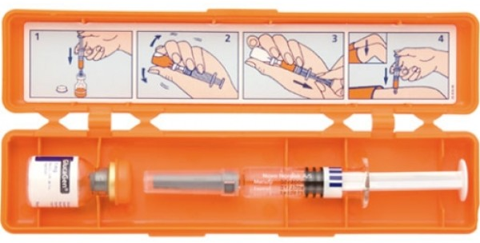  NOTE: this medication needs to be reconstituted prior to administration. Follow the instructions in the HypoKit®
MEDICATION NAME | GlucaGen® HypoKit® (Glucagon)
STRENGTH | 1mg/mL
DOSE | 0.5mL (≤ 5 years old) | 1mL (≥ 6years old)
ADMINISTRATION | IM (intramuscular injection)
ADMINISTRATION SUPPORT | health professional (i.e. Nurse, HSO) | trained school staff

AUTHORISATION AND RELEASE (MUST BE COMPLETED BY THE PARENT/LEGAL GUARDIAN)
 | The medication documented above is required to be administered during attendance at the education or care service.
 | I approve the release of this information to supervising staff and emergency personnel (if required).
 | I authorise the medication as instructed above to be administered in the education or care setting.
 | I certify the above statements are true and correct.
Legal guardian/
or adult student/client
First name (please print) Family name (please print)
Email or signature: |  | Date:

AGREEMENT: TREATING MEDICAL PRACTITIONER OR DIABETES NURSE EDUCATOR TO COMPLETE

 | I agree the medication instructions as written above are appropriate for administration in the education or care setting
(print name & practice/hospital or stamp)  Women’s and Children’s Hospital  Telephone (08) 8161 6402 |  | Date
 |  | Professional role
 |  | Email or signature

