Behaviour Management 2018

The following tables provide summary statistics relating to behaviour management incidents in South Australian Government schools during Term 2 2014-2018.

Suspension – from school means that the student does not attend school for a period of time ranging from one to five school days.
Exclusion – from a school means that the student does not attend that school for either a set period of time ranging from four to ten weeks OR for the remainder of a term, or for students over 16, the remainder of the semester.
Expulsion – from a single school means that the student who is over the age of compulsion does not attend school for a period of not less than six consecutive months to not more than eighteen consecutive months.

Expulsion – from all DECD schools means that the student who is over the age of compulsion is permanently expelled from attending all DECD schools.

Table 1: Suspensions, exclusions and expulsions, Term 2 2014-2018

 | 2014 | 2015 | 2016 | 2017 | 2018
Suspensions
Number of Students | 3,550 | 3,855 | 3,773 | 3,907 | 3,824
Number of Incidents | 4,651 | 5,141 | 5,025 | 5,295 | 5,051
Exclusions
Number of Students | 260 | 257 | 236 | 287 | 231
Number of Incidents | 261 | 258 | 236 | 294 | 233
Expulsions
Number of Students | 0 | 0 | 0 | 0 | 0
Number of Incidents | 0 | 0 | 0 | 0 | 0

Table 2: Percentage of population suspended and excluded, Term 2 2014-2018

 | 2014 | 2015 | 2016 | 2017 | 2018
Suspensions | 2.13% | 2.28% | 2.20% | 2.26% | 2.19%
Exclusions | 0.16% | 0.15% | 0.14% | 0.17% | 0.13%
Expulsions | 0.00% | 0.00% | 0.00% | 0.00% | 0.00%

Table 3: Frequency of students suspended, Term 2 2014-2018

Number of times suspended | 2014 | 2015 | 2016 | 2017 | 2018
1 | 2,752 | 2,914 | 2,848 | 2,928 | 2,920
2 | 581 | 682 | 670 | 690 | 657
3 | 154 | 194 | 194 | 211 | 189
4 | 49 | 50 | 51 | 50 | 45
5+ | 14 | 15 | 10 | 28 | 13
Total | 3,550 | 3,855 | 3,773 | 3,907 | 3,824

1
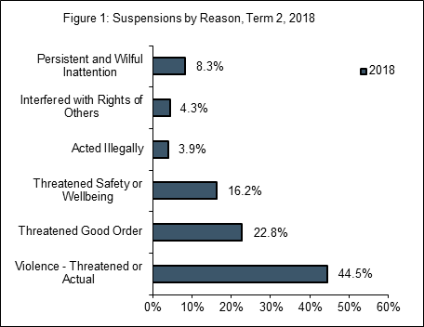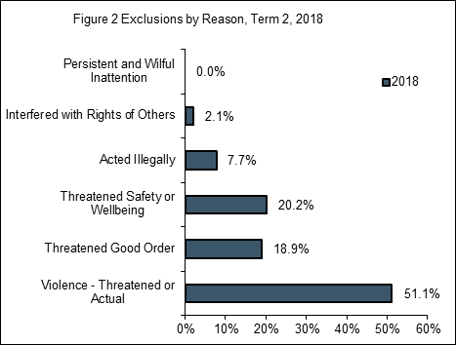

Table 4: Number of students suspended by Age*, Term 2 2018

Age Groups | Male | Female | Total | %
4-6 years | 189 | 33 | 222 | 5.7%
7-9 years | 593 | 111 | 704 | 18.0%
10-12 years | 826 | 202 | 1,028 | 26.3%
13-16 years | 1,275 | 544 | 1,819 | 46.5%
>16 years | 92 | 43 | 135 | 3.5%
Total | 2,975 | 933 | 3,908 | 100.0%

*Note: Age of student is calculated at the time of the incident, and students with multiple incidents may be reported in two age groups if their date of birth falls in Term 2.

Table 5: Reasons for suspensions (incidents)*, Term 2 2018

 | Number | %
Violence - Threatened or Actual | 2,246 | 44.5%
Threatened Good Order | 1,151 | 22.8%
Threatened Safety or Wellbeing | 820 | 16.2%
Acted Illegally** | 198 | 3.9%
Interfered with Rights of Others | 219 | 4.3%
Persistent and Wilful Inattention | 417 | 8.3%
Total | 5,051 | 100.0%

Note: Percentages may not sum to 100% due to rounding.
* Suspensions by reasons are only reported at the incident level (not student) due to significant double counting with some students being suspended several times for different incidents.
** Acted illegally is used for students over the age of ten when a principal believes that the student has committed an offence against the law and the police are involved.
Source for all tables and figures: DECD Term 3 School Enrolment Census 2014-2018

2

